John Wilson

CSCI 3287-310 Database Systems

Homework 2 Data Modelling

Data Model:

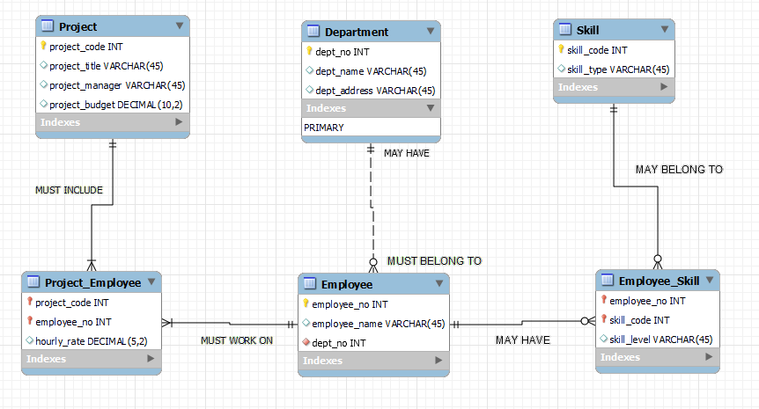

DDL:

-- MySQL Script generated by MySQL Workbench

-- Thu Jun 16 11:41:26 2022

-- Model: John Wilson Homework 2 Model Version: 1.0

-- MySQL Workbench Forward Engineering

SET @OLD_UNIQUE_CHECKS=@@UNIQUE_CHECKS, UNIQUE_CHECKS=0;

SET @OLD_FOREIGN_KEY_CHECKS=@@FOREIGN_KEY_CHECKS, FOREIGN_KEY_CHECKS=0;

SET @OLD_SQL_MODE=@@SQL_MODE, SQL_MODE='ONLY_FULL_GROUP_BY,STRICT_TRANS_TABLES,NO_ZERO_IN_DATE,NO_ZERO_DATE,ERROR_FOR_DIVISION_BY_ZERO,NO_ENGINE_SUBSTITUTION';

-- -----------------------------------------------------

-- Schema mydb

-- -----------------------------------------------------

DROP SCHEMA IF EXISTS `mydb` ;

-- -----------------------------------------------------

-- Schema mydb

-- -----------------------------------------------------

CREATE SCHEMA IF NOT EXISTS `mydb` DEFAULT CHARACTER SET utf8 ;

USE `mydb` ;

-- -----------------------------------------------------

-- Table `mydb`.`Department`

-- -----------------------------------------------------

DROP TABLE IF EXISTS `mydb`.`Department` ;

CREATE TABLE IF NOT EXISTS `mydb`.`Department` (

`dept_no` INT NOT NULL,

`dept_name` VARCHAR(45) NULL,

`dept_address` VARCHAR(45) NULL,

PRIMARY KEY (`dept_no`))

ENGINE = InnoDB;

-- -----------------------------------------------------

-- Table `mydb`.`Employee`

-- -----------------------------------------------------

DROP TABLE IF EXISTS `mydb`.`Employee` ;

CREATE TABLE IF NOT EXISTS `mydb`.`Employee` (

`employee_no` INT NOT NULL,

`employee_name` VARCHAR(45) NULL,

`dept_no` INT NOT NULL,

PRIMARY KEY (`employee_no`),

INDEX `fk_Employee_Department1_idx` (`dept_no` ASC) VISIBLE,

CONSTRAINT `fk_Employee_Department1`

FOREIGN KEY (`dept_no`)

REFERENCES `mydb`.`Department` (`dept_no`)

ON DELETE NO ACTION

ON UPDATE NO ACTION)

ENGINE = InnoDB;

-- -----------------------------------------------------

-- Table `mydb`.`Project`

-- -----------------------------------------------------

DROP TABLE IF EXISTS `mydb`.`Project` ;

CREATE TABLE IF NOT EXISTS `mydb`.`Project` (

`project_code` INT NOT NULL,

`project_title` VARCHAR(45) NULL,

`project_manager` VARCHAR(45) NULL,

`project_budget` DECIMAL(10,2) NULL,

PRIMARY KEY (`project_code`))

ENGINE = InnoDB;

-- -----------------------------------------------------

-- Table `mydb`.`Skill`

-- -----------------------------------------------------

DROP TABLE IF EXISTS `mydb`.`Skill` ;

CREATE TABLE IF NOT EXISTS `mydb`.`Skill` (

`skill_code` INT NOT NULL,

`skill_type` VARCHAR(45) NULL,

PRIMARY KEY (`skill_code`))

ENGINE = InnoDB;

-- -----------------------------------------------------

-- Table `mydb`.`table1`

-- -----------------------------------------------------

DROP TABLE IF EXISTS `mydb`.`table1` ;

CREATE TABLE IF NOT EXISTS `mydb`.`table1` (

)

ENGINE = InnoDB;

-- -----------------------------------------------------

-- Table `mydb`.`Project_Employee`

-- -----------------------------------------------------

DROP TABLE IF EXISTS `mydb`.`Project_Employee` ;

CREATE TABLE IF NOT EXISTS `mydb`.`Project_Employee` (

`project_code` INT NOT NULL,

`employee_no` INT NOT NULL,

`hourly_rate` DECIMAL(5,2) NULL,

PRIMARY KEY (`project_code`, `employee_no`),

INDEX `fk_Project_has_Employee_Employee1_idx` (`employee_no` ASC) VISIBLE,

INDEX `fk_Project_has_Employee_Project_idx` (`project_code` ASC) VISIBLE,

CONSTRAINT `fk_Project_has_Employee_Project`

FOREIGN KEY (`project_code`)

REFERENCES `mydb`.`Project` (`project_code`)

ON DELETE NO ACTION

ON UPDATE NO ACTION,

CONSTRAINT `fk_Project_has_Employee_Employee1`

FOREIGN KEY (`employee_no`)

REFERENCES `mydb`.`Employee` (`employee_no`)

ON DELETE NO ACTION

ON UPDATE NO ACTION)

ENGINE = InnoDB;

-- -----------------------------------------------------

-- Table `mydb`.`Employee_Skill`

-- -----------------------------------------------------

DROP TABLE IF EXISTS `mydb`.`Employee_Skill` ;

CREATE TABLE IF NOT EXISTS `mydb`.`Employee_Skill` (

`employee_no` INT NOT NULL,

`skill_code` INT NOT NULL,

`skill_level` VARCHAR(45) NULL,

PRIMARY KEY (`employee_no`, `skill_code`),

INDEX `fk_Employee_has_Skill_Skill1_idx` (`skill_code` ASC) VISIBLE,

INDEX `fk_Employee_has_Skill_Employee1_idx` (`employee_no` ASC) VISIBLE,

CONSTRAINT `fk_Employee_has_Skill_Employee1`

FOREIGN KEY (`employee_no`)

REFERENCES `mydb`.`Employee` (`employee_no`)

ON DELETE NO ACTION

ON UPDATE NO ACTION,

CONSTRAINT `fk_Employee_has_Skill_Skill1`

FOREIGN KEY (`skill_code`)

REFERENCES `mydb`.`Skill` (`skill_code`)

ON DELETE NO ACTION

ON UPDATE NO ACTION)

ENGINE = InnoDB;

SET SQL_MODE=@OLD_SQL_MODE;

SET FOREIGN_KEY_CHECKS=@OLD_FOREIGN_KEY_CHECKS;

SET UNIQUE_CHECKS=@OLD_UNIQUE_CHECKS;